SIMATS ENGINEERING
ASSESSMENT TOOL 1- Enumeration Analysis
COURSE NAME: Ethical Hacking COURSE CODE: ITA14
______________________________________________________________________________________
COURSE OUTCOME COVERED
CO3: Analyse network services using port scanning, ping sweeps, and enumeration techniques across different operating systems to identify vulnerabilities. (BL3)
Assessment Tool Weightage: 40%
QUESTIONS: 5 Total Marks:100
______________________________________________________________________________________
Code of Conduct:
I M.SHARMILA (192572139) certify that this submission is my original work and that I have adhered to the guidelines specified for this assessment. I understand that any violation of academic integrity rules will result in disciplinary action.
Signature of the student:M.sharmila

1. A cyber security consulting company has been contracted to perform an initial security assessment of the publicly accessible server scanme.nmap.org. Before conducting any vulnerability assessment, the client requires a detailed enumeration report. Using Nmap, perform host discovery, TCP port scanning, service version detection, operating system fingerprinting, and default script scanning on scanme.nmap.org. Discuss how a threat actor could utilize the information gathered during enumeration to launch further attacks such as service exploitation, brute-force attacks, or vulnerability discovery. Prepare a technical report summarizing your findings, attack surface analysis, risk assessment, and recommendations for securing the server.

Objective
To perform reconnaissance of scanme.nmap.org and collect information about its network services using Nmap.
Target: scanme.nmap.org
Tool: Nmap

i. Host Check

Command 1 : nmap -sn scanme.nmap.org

Result:
The host was detected as active.

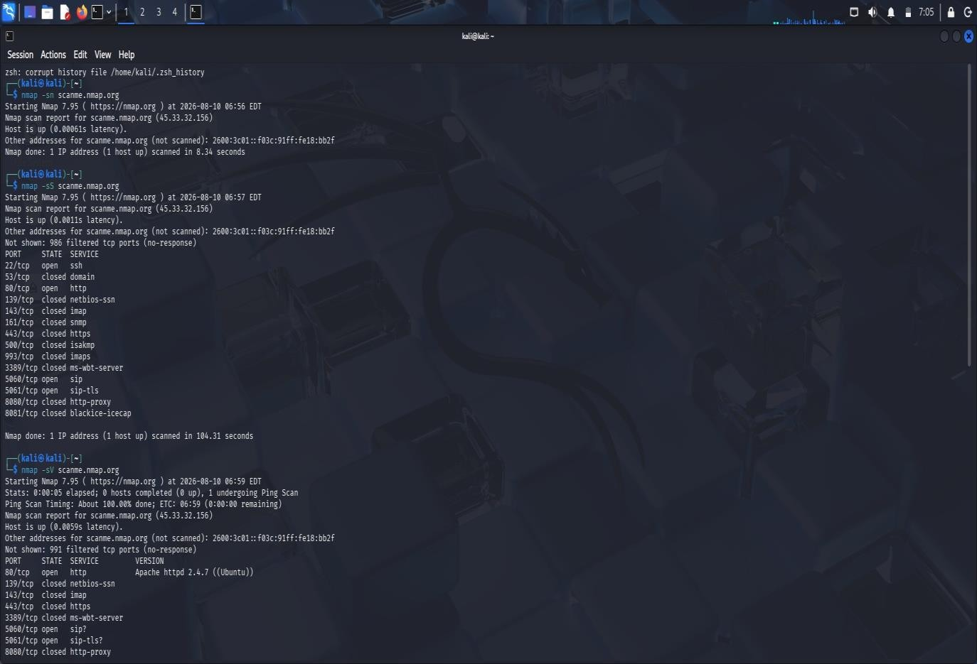
ii. TCP Enumeration
Command 2 : nmap -sS scanme.nmap.org

Result:
The scan displayed the TCP ports and their current states.
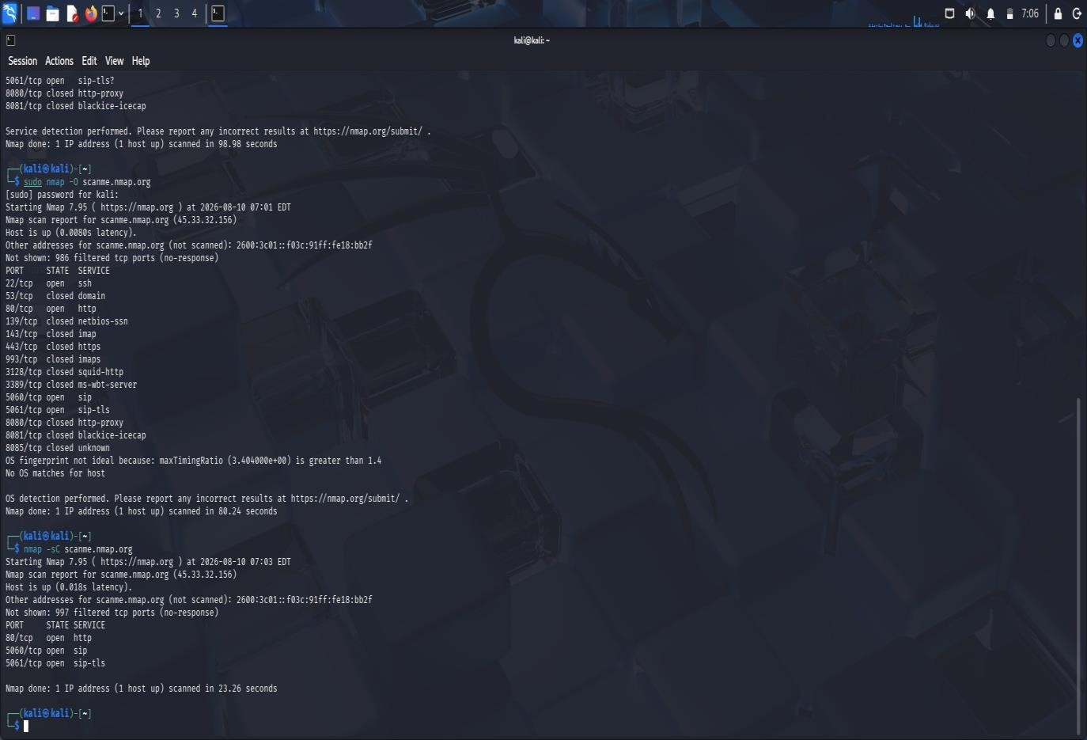

Port Details:
TCP Port | Service | Status
22 | SSH | Open
80 | HTTP | Open

iii. Identify Running Services , Identify OS, Default NSE Scripts
Command 3 : nmap -sV scanme.nmap.org

Command 4 : sudo nmap -O scanme.nmap.org
Command 5 : nmap -sC scanme.nmap.org

Result:
- Nmap determined the service information associated with the discovered ports.
- OS fingerprinting was performed to determine the probable operating-system family.
- Nmap's default scripts collected additional service information.

Security Observations
The enumeration showed which services are exposed to the Internet. This information can be useful to an attacker for reconnaissance, vulnerability research, and identifying possible authentication attack targets.

Security Measures
- Remove services that are not required.
- Restrict remote administration access.
- Apply security patches regularly.
- Configure a firewall using least privilege.
- Monitor suspicious connection attempts.

Final Result
Nmap provided useful information about the target's network exposure, including reachable services, ports, service information, and OS characteristics. The assessment demonstrates the importance of minimizing and securing publicly exposed services.
2. The security team has deployed a deliberately vulnerable Linux server, 192.168.56.101 (Metasploitable 2), in an isolated laboratory environment to train penetration testers. As part of the pre-engagement reconnaissance phase, use Nmap to perform comprehensive enumeration of 192.168.56.101. Identify all open ports, running services, service versions, and operating system information. Analyze the purpose of each service and determine which services could provide potential entry points for an attacker. Categorize the discovered services into High, Medium, and Low risk levels based on their exposure and functionality. Explain how the enumeration results could guide a penetration tester in selecting potential attack vectors and exploitation strategies.
Objective :
To perform comprehensive enumeration of the Metasploitable 2 Linux server using Nmap and identify its open ports, running services, service versions, operating system, and potential security risks.
Target : Metasploitable 2
IP Address : 192.168.56.102
Network : Host-Only Adapter
Tool : Nmap

Procedure
- Installed Metasploitable 2 in VirtualBox.
- Connected Kali and Metasploitable using a Host-Only network.
- Verified the target IP as 192.168.56.102.
- Tested connectivity using : ping -c 4 192.168.56.102
- Confirmed the host was active using : nmap -sn 192.168.56.102
- Performed Nmap enumeration to identify ports, services, versions, OS information, and NSE results.

Commands and Results

A. Host Discovery
Command : nmap -sn 192.168.56.102
Result : The target was found to be active.
B. TCP Port Scanning
Command : sudo nmap -sS -p- 192.168.56.102
Result : Nmap identified the open TCP ports on the target.
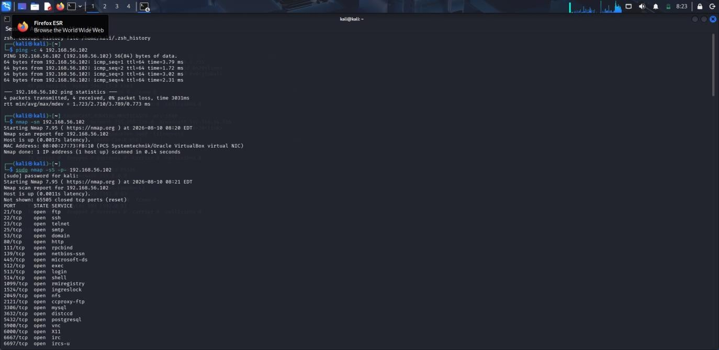

C. Service Version Detection
Command : sudo nmap -sV 192.168.56.102
Result : The services and their versions were identified.

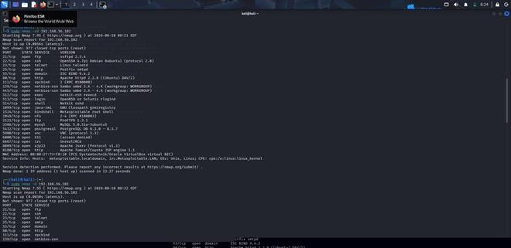

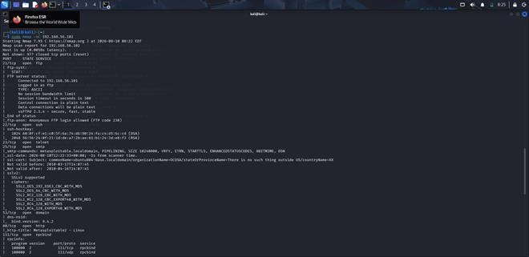

D. Operating System Detection
Command : sudo nmap -O 192.168.56.102
Result : Nmap identified the target as a Linux-based system.
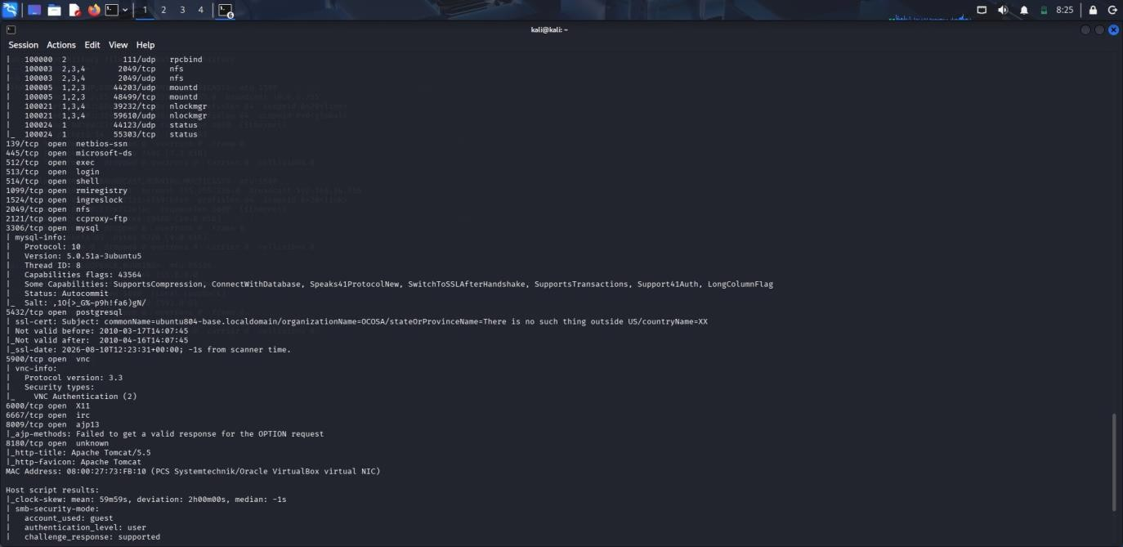

E. Default NSE Scripts
Command : sudo nmap -sC 192.168.56.102
Result : Default NSE scripts provided additional information about the services.

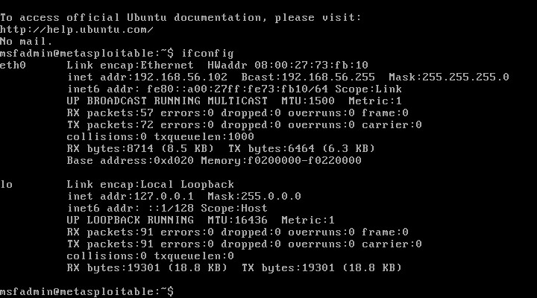

Security Attack Analysis :
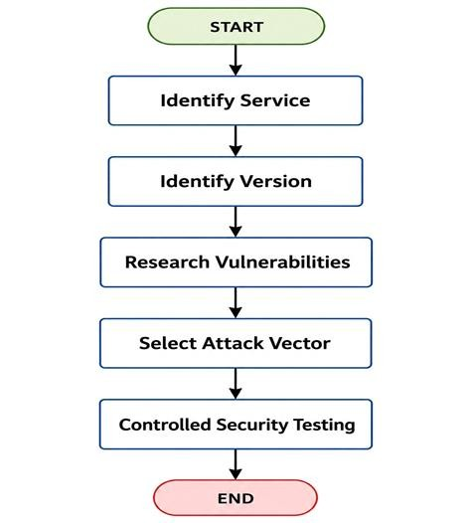

Service Risk Analysis :
- FTP : File transfer - High risk
- Telnet : Remote login - High risk
- HTTP : Web service - High risk
- Database : Data storage/access - High risk
- SSH : Secure remote administration - Medium risk
- SMTP : Mail communication - Medium risk
- DNS : Name resolution - Medium risk

Recommendations
- Disable unnecessary services.
- Replace Telnet with SSH.
- Restrict database services from network access.
- Keep all software updated.
- Use strong authentication.
- Configure firewall rules.

Conclusion
Nmap successfully identified the active host, open ports, running services, service versions, and operating-system information of the Metasploitable 2 server. The discovered services represent different levels of security risk and provide potential entry points that should be prioritized during authorized penetration testing.
3. A financial organization wants to assess the security posture of a Windows workstation located at 192.168.56.102 before connecting it to the production network. Using Nmap, enumerate 192.168.56.102 to identify active ports, network services, file-sharing protocols, remote management services, and operating system details. Analyze whether the discovered services comply with the principle of least privilege and identify any services that may unnecessarily increase the attack surface. Discuss how an attacker could leverage the identified services for reconnaissance, lateral movement, or unauthorized access. Based on your findings, propose a set of security hardening measures to improve the system's resilience against cyberattacks

Objective
The objective was to assess the security of the Windows workstation 192.168.56.102 before connecting it to the production network. Nmap was used to identify open ports, services, filesharing services, remote-management services, and OS details.
Target: 192.168.56.102

Tool: Nmap
i. Commands :

Scanning | Commands
Host Availability Scan | ping -c 4 192.168.56.102
TCP Port Scan | sudo nmap -Pn -sV -sC -p 5060,5061 192.168.56.102
Service Version Scan | sudo nmap -Pn -sV -sC -p 5060,5061 192.168.56.102
Windows Services Scan | sudo nmap -Pn -sS -sV -p 135,139,445,3389,5985,5986,22 192.168.56.102
OS Detection Scan | sudo nmap -Pn -O --osscan-guess 192.168.56.102
UDP Service Scan | sudo nmap -Pn -sU -sV -p 5060,5061 192.168.56.102

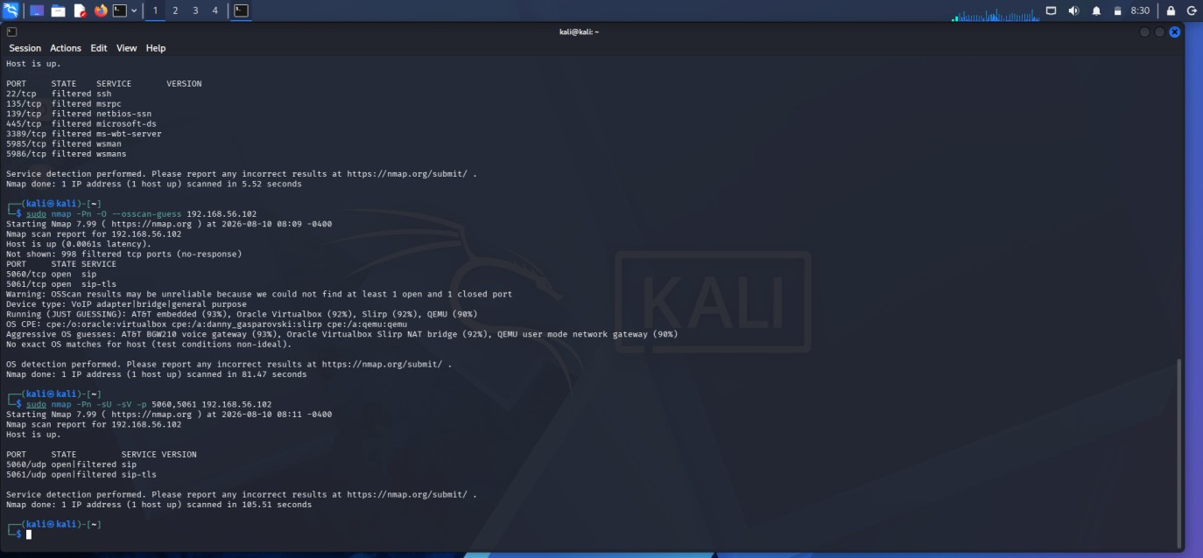
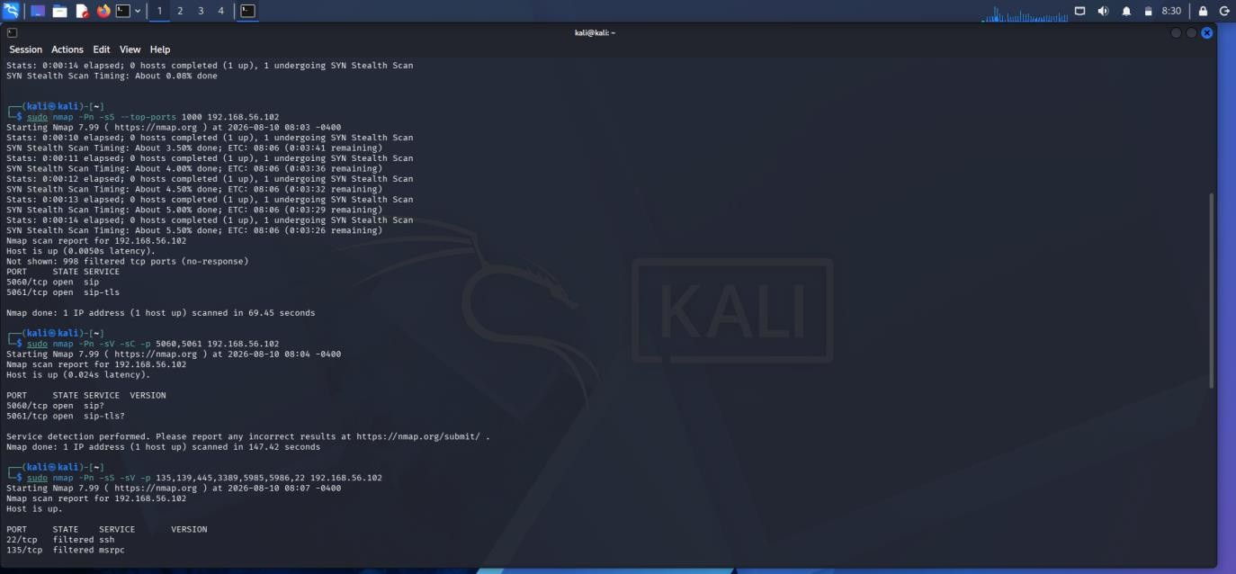
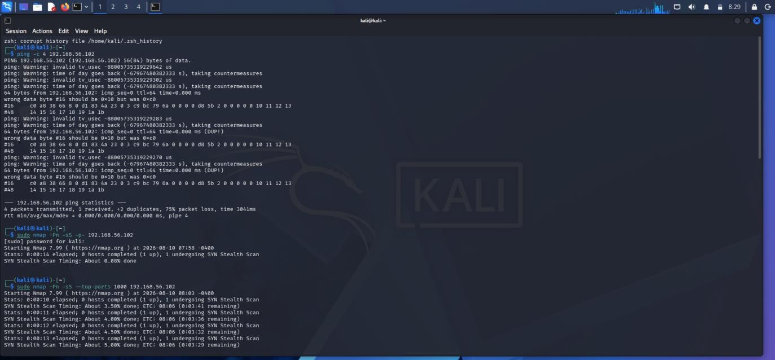

ii. Security Analysis
- Ports 5060 and 5061 are the main exposed services. If SIP/VoIP is not required on this workstation, these services unnecessarily increase the attack surface.
- The SMB, RDP, WinRM, SSH, and NetBIOS ports were filtered, reducing direct exposure to common file-sharing and remote-management attacks.
- An attacker could use exposed SIP services for network reconnaissance and, if the service is vulnerable or poorly configured, potentially attempt unauthorized access or further attacks.

iii. Recommendations
- Disable SIP services if they are not required.
- If required, allow access only from authorized systems.
- Keep SIP software updated and securely configured.
- Maintain firewall restrictions on SMB, RDP, WinRM, and other unnecessary services.
- Disable unnecessary Windows services.
- Use network segmentation and strong authentication.
- Perform another Nmap scan after hardening.

iv. Conclusion
The workstation has a limited exposed attack surface, with SIP-related ports 5060 and 5061 being the main open services. SMB, RDP, WinRM, SSH, and NetBIOS were filtered. Unnecessary SIP services should be disabled or restricted to follow the principle of least privilege and improve the workstation's security before connecting it to the production network.
4. An organization hosts a web application on 192.168.56.103 (OWASP Juice Shop Server) and plans to conduct a full penetration test. Before the testing phase begins, the security team must understand the server's network exposure. Using Nmap, perform a detailed enumeration of 192.168.56.103, including host discovery, port scanning, service version detection, operating system fingerprinting, and web service identification. Analyze the discovered services and determine how they support the hosted web application. Evaluate the risks associated with exposed web services, administrative interfaces, and supporting services. Explain how the information gathered during enumeration could be used to identify potential vulnerabilities in the web application environment and recommend measures to minimize exposure.

Objective
The objective of this assessment is to enumerate the OWASP Juice Shop server (192.168.56.103) using Nmap and identify its network exposure, open ports, running services, service versions, operating system, and web services.

Tools Used
Kali Linux , Nmap , OWASP Juice Shop
Target IP: 192.168.56.103

Enumeration Procedure
- Host Discovery : nmap -sn 192.168.56.103
Result : This confirms whether the target server is active.
- Port Scanning : nmap -p- 192.168.56.103
Result : This scans all 65,535 TCP ports and identifies accessible services.
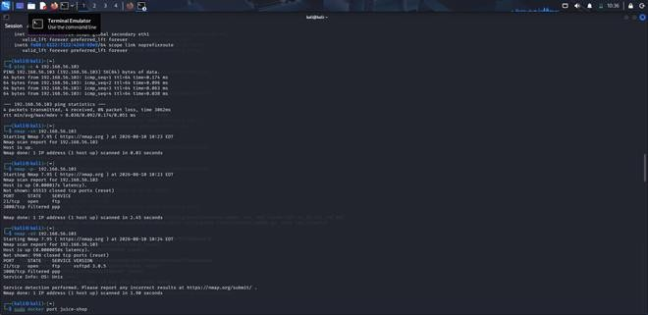

iii. Service and Version Detection : nmap -sV 192.168.56.103
Result : This identifies the services running on open ports and their versions. iv. OS Detection : sudo nmap -O 192.168.56.103
Result : This attempts to identify the operating system of the target server.

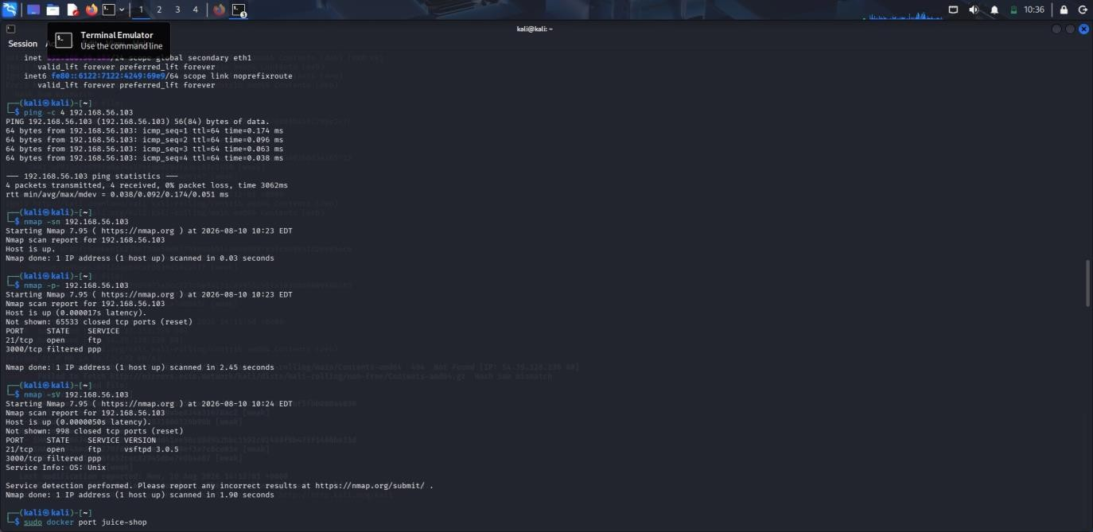



v. Web Service Identification : nmap -p 80,443,3000 --script=http-title,http-server-header 192.168.56.103
Result : This identifies HTTP services, page titles, and server information.
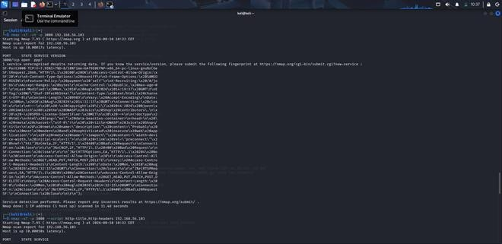
- sudo nmap -sT -O 192.168.56.103
- sudo nmap -sT -A 192.168.56.103
- curl -I http://192.168.56.103:3000
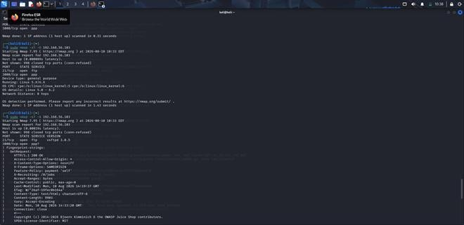

Findings
The enumeration provides information about the server's open ports, services, versions, and web application interfaces. The web service is particularly important because it provides direct access to the OWASP Juice Shop application.

Security Analysis
- The discovered services provide an attacker with useful information about the target environment. Service versions can be compared with known vulnerabilities and security advisories.
- Exposed web services can be further assessed for vulnerabilities such as authentication weaknesses, injection, broken access control, cross-site scripting, and security misconfiguration.
- Administrative services such as SSH increase the attack surface if they are unnecessarily exposed or poorly configured.
- Development or supporting services running on non-standard ports should also be reviewed to determine whether they are required.

Recommendations
- Disable unnecessary open ports and services.
- Restrict administrative services such as SSH to trusted networks.
- Keep the operating system and application dependencies patched.
- Use HTTPS with secure TLS configuration.
- Minimize server/version information exposed through HTTP headers.
- Apply firewall rules and network segmentation.
- Regularly scan the server to identify newly exposed services.

Conclusion
Nmap enumeration successfully provides a network-level view of the OWASP Juice Shop server. The information collected helps identify the server's attack surface and provides a foundation for the next phase of penetration testing. The exposed web service should receive particular attention because it directly hosts the application, while unnecessary administrative and supporting services should be restricted to minimize the overall attack surface.

5. The network gateway device at 192.168.56.1 serves as the primary access point between the internal laboratory network and external networks. The network administrator suspects that unnecessary management services may be exposed. Using Nmap, conduct a comprehensive enumeration of 192.168.56.1, including port scanning, service detection, operating system fingerprinting, and script-based enumeration. Identify all exposed management interfaces, network services, and accessible resources. Analyze the security implications of exposing services such as SSH, Telnet, SNMP, HTTP, or HTTPS management interfaces. Discuss how attackers could exploit misconfigured management services to gain unauthorized access to the network infrastructure. Based on your analysis, recommend security controls and best practices to secure the gateway device and reduce the risk of compromise.
Objective :
To enumerate the gateway device 192.168.56.1 using Nmap, identify exposed ports and services, detect management interfaces, perform OS and script-based enumeration, analyze security risks, and recommend controls to reduce the attack surface.
- Host Discovery : sudo nmap -sn 192.168.56.1
Purpose: Checks whether the target host is active and reachable.
Result: Host 192.168.56.1 is UP.
- TCP Port Scan : sudo nmap -Pn -T4 --top-ports 1000 192.168.56.1
Purpose: Scans the 1,000 most common TCP ports to identify exposed services.
Result: 8 TCP ports were found open: 135, 139, 445, 2179, 2869, 3306, 5357, 16992.
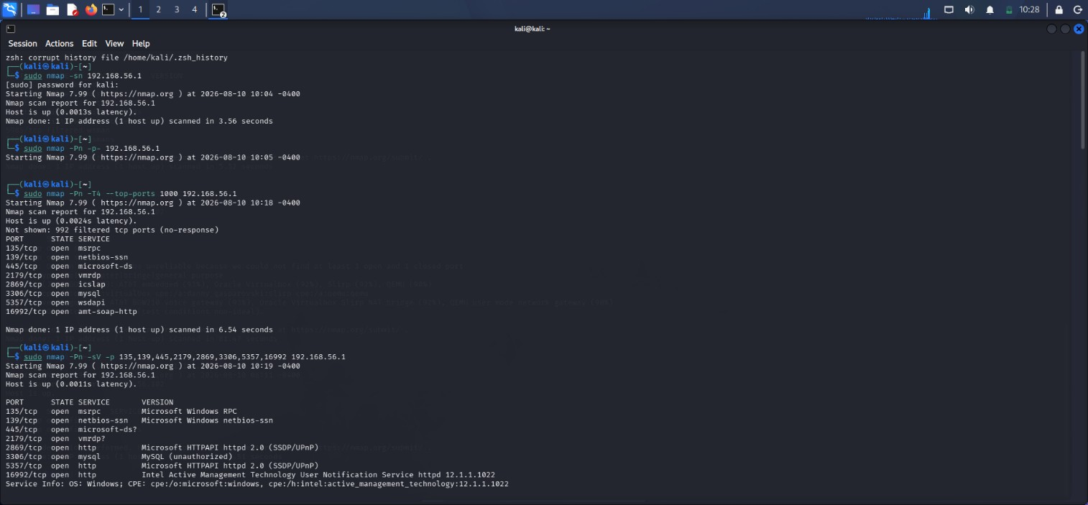

- Service and Version Detection : sudo nmap -Pn -sV -p 135,139,445,2179,2869,3306,5357,16992
192.168.56.1
Purpose: Identifies the services and available version information running on open ports.
- UDP Port Scan : sudo nmap -Pn -sU --top-ports 100 192.168.56.1
Purpose: Identifies commonly exposed UDP services such as NTP, NetBIOS, IKE and UPnP.
Result: UDP 1900 was confirmed open for UPnP; several other ports were reported as open/filtered.
- Operating System Detection : sudo nmap -Pn -O 192.168.56.1
Purpose: Attempts to identify the operating system and device type.
Result: OS detection was inconclusive. Nmap suggested possible gateway/bridge/virtualized device types, but no exact OS match was confirmed.
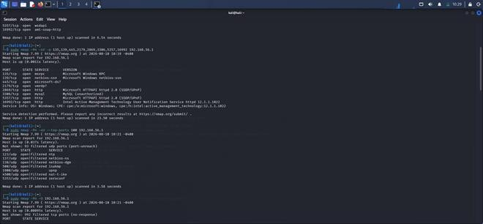
- Default NSE Script Enumeration : sudo nmap -Pn -sC -sV -p 135,139,445,2179,2869,3306, 5357, 16992 192.168.56.1
Purpose: Uses Nmap's default scripts along with service detection to collect additional information about exposed services.
Result: SMB security information, HTTP information and Intel AMT information were identified.

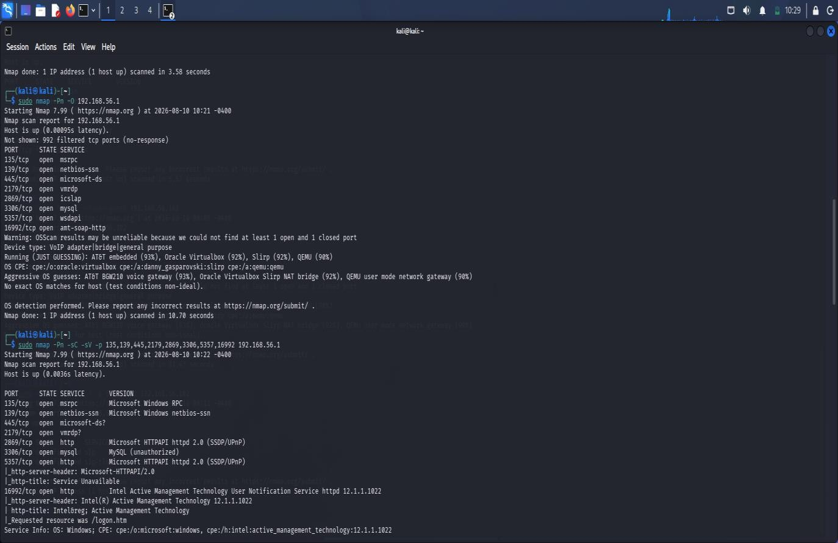
- Management Port Check : sudo nmap -Pn -sV -p 22,23,80,443,161,162 192.168.56.1
Purpose: Checks common management services such as SSH, Telnet, HTTP, HTTPS and SNMP.
Result: All checked management ports were closed.

- SMB Security Enumeration : sudo nmap -Pn -p 139,445 --script smb-protocols,smb2-securitymode,smb2-time 192.168.56.1
Purpose: Identifies SMB versions and checks SMB security settings.
Result: SMB 3.1.1 message signing was enabled and required.

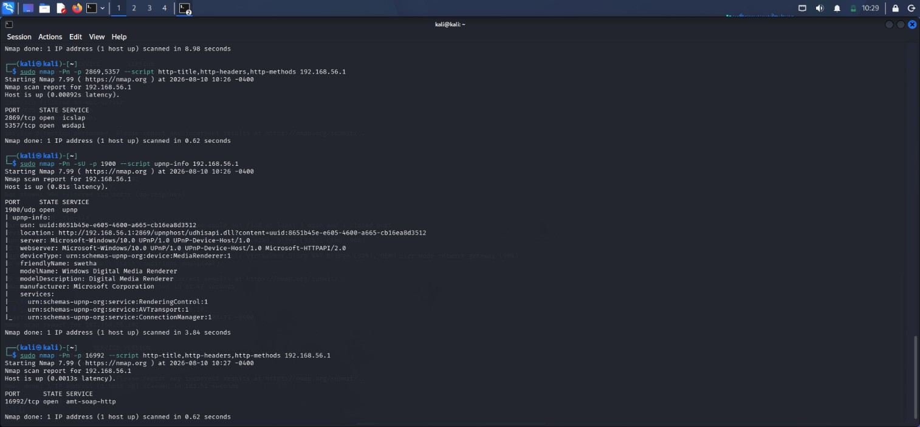

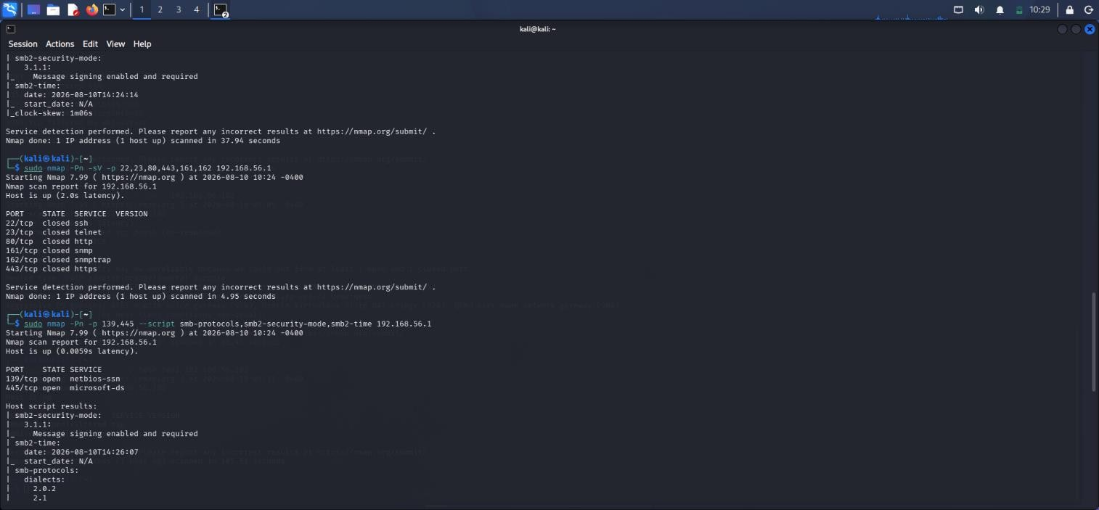

Service Risk Analysis
- 135 - MSRPC: Windows communication service;
- 139 - NetBIOS: Supports network sharing; can help attackers gather information.
- 445 - SMB: File-sharing service; exposed SMB may allow unauthorized access.
- 2179 - VMRDP: Service not fully identified, should be checked , disabled if unused.
- 2869/5357 - HTTPAPI/UPnP: may expose system details.
- 3306 - MySQL: Database service; should only be accessible to authorized systems.

Security Implications
The exposed services increase the gateway's attack surface. An attacker with network access could perform service enumeration, authentication attacks, or exploit vulnerable services. SMB, MySQL, UPnP, and Intel AMT are the main services requiring attention.

Recommended Security Controls
- Disable unnecessary services and ports.
- Restrict SMB/NetBIOS to trusted systems.
- Restrict MySQL to authorized hosts.
- Disable UPnP if not required.

Conclusion
The assessment found several exposed TCP and UDP services on 192.168.56.1. SSH, Telnet, HTTP, HTTPS, and SNMP were closed, but SMB, MySQL, UPnP, and Intel AMT were accessible.
Restricting unnecessary services and applying proper firewall, authentication, patching, and network segmentation controls will reduce the gateway's security risk.

